**Course Project – Comparing Data Sets**

Shaun Pritchard

Rasmussen College

QMB3300

Jerome Olorunmaiye

May 28, 2020

**Course Project – Comparing Data Sets**

**Discuss the key differences between quantitative and qualitative data.**

Quantitative data is statistical and is typically structured in nature – meaning it is more rigid and defined. This type of data is measured using numbers and values, which makes it a more suitable candidate for data analysis. Whereas qualitative is open for exploration, quantitative data is much more concise and close-ended. It can be used to ask the questions “how much” or “how many,” followed by conclusive information. Quantitative data is any quantifiable information that can be used for mathematical calculation or statistical analysis. This form of data helps in making real-life decisions based on mathematical derivations. Quantitative data is used to answer questions like how many? How often? How much? This data can be validated and verified.

Qualitative data is non-statistical and is typically unstructured or semi-structured in nature. This data is not necessarily measured using hard numbers used to develop graphs and charts. Instead, it is categorized based on properties, attributes, labels, and other identifiers. Qualitative data can be used to ask the question “why.” It is investigative and is often open-ended until further research is conducted. Generating this data from qualitative research is used for theorizations, interpretations, developing hypotheses, and initial understandings. Qualitative data is about the emotions or perceptions of people, what they feel. In quantitative data, these perceptions and emotions are documented. It helps the market researchers understand the language their consumers speak and deal with the problem effectively and efficiently. The 2 datasets I have acquired from ei.gov show both quantitative and qualitative data.

**From the quantitative data set you chose, include a visual graphic example in your paper. Explain what makes it quantitative.**

The dataset which provides quantitative data is called *“State Total Energy Rankings, 2017”*. This data shows discrete quantifiable data that can be used for mathematical calculations including downloadable CSV data sheet with all accurate, historical, and approximate data that can be used to perform statistical analysis and regression. Also, this data can be used for developing rankings for each state. Based off consumption of power and derivatives of multiple power generating sources. This dataset shows quantitative metrics on production consumption and expenditures based on all energy being consumed for each state and U.S territory individually *(EIA, 2020)*.

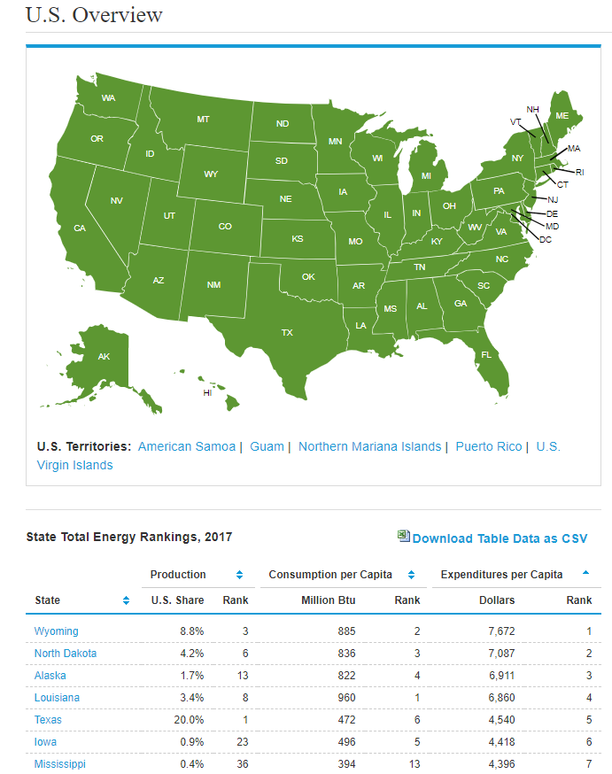

**From the qualitative data set, include a visual graphic example in your paper. Explain what makes it qualitative.**

The qualitative data set I have chosen is called *“EIA’s residential energy survey”* which includes estimates through visualization for a variety of end-user appliances that are used to consume power. This qualitative dataset shows a quick visual reference of the devices in the entire country which consume more power when activated and used. Such as Air conditioning, TVs, lighting, water heating, refrigerators, and so on. This data is categorized as end-user data and only shows approximate estimates of percentages of the devices which consume power. This is used to give the visualization an interpretation on which category of end user devices account for high power consumption in residential homes across the US in 2015 *(eia, 2015)*.

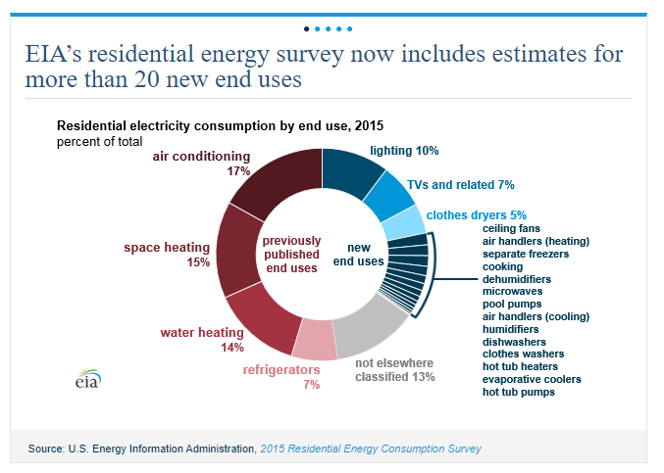

**Point out potential pitfalls of the energy consumption survey data.**

1. **Quantitative pitfalls**

Reduce the production values used by the total state energy production value plus a ranking value based on every individual U.S state. Texas Pennsylvania and Wyoming being the top three states of production. With Texas at 20% production rate. This production value shows the how much production based on energy consumption each state produces. Intern contributing to the overall facilitation of energy.

Other pitfalls are the consumption per capita but this data we can see that states like Louisiana which only have 3.4% consume more energy per capita by 960 million Btu's. With this data we can deduce which states consume more electrical energy as compared to those States do you use less electricity or have higher production values. We also get approximate data from the download data table CSV reports which goes into more detail breaking down the consumption of energy courage State and further and methods of production also the resources implemented such as renewable, nuclear, or natural gases. The data reveals summary reports based on statistical testing and Analysis. The final category of data is expenditures. It also quantifies per-capita per each state inquiring the consumption and production values a dollar amount and ranking based on a dollar amount to account for cost and spending.

**A simple quick visual analysis of EIA’s quantitative data:**

* I can deduce that Texas ranked number one with a 20% production value being produced in the state.
* Louisiana ranked number one for the highest consumption per capita 960 million BTUs for the current year.
* Wyoming has the highest expenditure with the production rate of 8.8%, 885 million BTUs consumption rate, and the highest expenditure of $7672.

1. **Qualitative pitfalls**

The qualitative pitfalls I can derive are based on the end-user appliance of residential electricity consumption. With such appliances air conditioning, water heating, space heating, refrigerators, lighting, TVs, and other related energy-consuming appliances. Including new and used appliances such a ceiling fans, air handler, cooking, microwaves, dishwashers, and many others.

A quick visual representation of those categories of data shows us quick visualization to a minimum, mean, and maximum percentages of appliance energy consumption with a donut chart. Though these are approximated, or estimate based on survey data. We can determine quick analysis have appliances that may very well affect each common US residential household.

**A quick analysis of EIA’s qualitative data reveals:**

* Air conditioners consume 17% of the electricity accounting for the largest amount.
* Refrigerators account for a mean value of 7% of electrical power consumption.
* Clothes dryers account for at least at 5% of residential energy consumption

There are even smaller determinants based off the new end user appliances which are all below 5% and above 0%.

With either set of data we can determine if the state we live in implements sustainable practices or may need to employ more. We can see that running my air conditioner at my own home probably accounts for a lot of electrical costs as well as many other appliances? With this data I can look for new ways to be sustainable myself in my home in utilizing these appliances. Regardless if I needed to do complete hard statistical analysis for state revenue, consumption, and production. Quantitative data provided would allow me to yield results. Whereas With the surveyed estimated data I can get a quick visualization of categorical data based on residential appliances.

# References

eia. (2015). *RESIDENTIAL ENERGY CONSUMPTION SURVEY (RECS)*. Retrieved from eia.gov: https://www.eia.gov/consumption/residential/index.php

EIA. (2020). *Current Issues & Trends*. Retrieved from https://www.eia.gov/nuclear/: https://www.eia.gov/nuclear/

EIA. (2020). *Electricty Consumption*. Retrieved from https://www.eia.gov: https://www.eia.gov/international/data/country/USA/electricity/electricity-consumption?pd=2&p=0000002&u=0&f=A&v=mapbubble&a=-&i=none&vo=value&&t=C&g=none&l=249--238&s=315532800000&e=1514764800000

EIA. (2020). *electricty data*. Retrieved from www.eia.gov: https://www.eia.gov/nuclear/

EIA. (2020). *U.S. Overview*. Retrieved from www.eia.gov: https://www.eia.gov/state/

EIA. (2020). *Wind became the third-largest source of U.S generation capacity in 2019, surpassing nuclear capacity*. Retrieved from https://www.eia.gov/electricity/monthly/update/archive/april2020/: https://www.eia.gov/electricity/monthly/update/archive/april2020/